CSC3320 System Level Programming

Lab Assignment 11 - Out of lab

Instructor: Fil Rondel

Due on 4/16/21 at 11:59PM

Run the following examples through your Homework 4. Parts in this assignment correspond to programs in Homework 4.

Part 1:

1. unsafepass

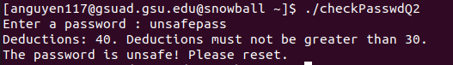

The passwords contains lower case letters and does not have more than 2 consecutive characters. However, there is no upper-case character and no number. Each criteria missed is 20 points deduction. Since two criteria is missing, 40 points is deducted. To declare the password safe, the password must not be deducted more than 30 points.

1. SafePaswd0192837465



The password contains lower case letters, upper case letters, numbers, and contains seemingly no more than 2 consecutive characters. Therefore 0 points is deducted so the password is declared as safe since 0 points deducted is less than 30.

1. bbppddqq11223344



The password has lower case letter, numbers, and no more than 2 consecutive characters. However, it has no upper-case letter. 20 points out of a maximum allowance of 30 points has been deducted so the password has been deemed as safe.

1. T20s9Q02lwmc2a



This password contains lower case, upper case letter, number, and seemingly no more than 2 consecutive characters. It requires no more than 30 points deducted and missing a criterium deducts 20 points to be labeled as safe. 0 points are deducted. Therefore the password is declared safe.

Part 2:

1. radar

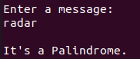

A palindrome reads the message the same backward as forward.

The message “radar” has r at the end of both sides, a at the second to end of both sides, and d in the middle. Spelling “radar” backwards spells “radar”. Therefore, it is a palindrome.

1. Gateman sees name, garageman sees name tag

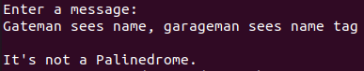

If the spaces, case letter, and comma was ignored, the message is read the same backwards as forward. However, the program created does not consider the circumstances that the message contains any spaces, case letter, and comma. It is only considering characters, numeric or alphanumeric. Therefore, the string when interpreted does not match character by character when comparing displacement from both end to one another.

Hence, the output is declared as not a palindrome.

1. Some men interpret fine memos



The character “f” is not in the center and there is only one f so if read backwards, the message would not be the same as the original. This is also assuming that capital letters, spaces, and period can be ignored in which cannot be ignored.

The output is declared not a palindrome.

1. Do geese see God?

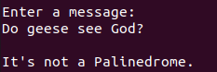

If question mark, upper case letters, and spaces were ignored, it would be a palindrome. The program does not consider ignoring the question mark, upper case letters, and spaces.

Therefore the program declares the message not a palindrome.

Part 3:

1. 47



If the code inputted matches the code associated with a certain array index, the array index prints out the country name of that certain array index.

If there are no codes matching, there is an error message saying “No corresponding country found” to indicate there is no countries on the list that matches the inputted code to be printed out as a message.

47 did not match any of the listed countries and their respective code.

1. 354



354 did not match any of the listed countries and their respective code thus no countries with the inputted code has been displayed.

1. 420



420 did not match any of the listed countries with their identifying code. So, no counties with their respective code has been printed using the inputted code.

1. 372



The inputted code 372 did not match any of the codes belonging to the respective countries listed within the database of the program. Hence, the resulting message of there being no country with the inputted code being found is given instead.

Note: Please follow the instructions, write a report by answering the questions and upload the report (named as Lab11_FirstNameLastName.pdf or .doc) to the Google Classroom Out of Lab Assignment folder 

Please add the lab assignment NUMBER and your NAME at the top of your file sheet.